  Provee Mobile Marketplace  Project Report | Abstract  Information System Design Report of an online mobile service marketplace where users and service providers meet

Submitted By: Mansi Rathi
Moushumi Bhattacharya
Monica Jain
Josh Wang

Contents
Problem Statement 2

Problem Statement

Service market being traditionally fragmented in nature, it is dependent on various middlemen who dictate the pricing of a service. Skilled professionals lack the privilege to fulfill services based on their liking and remuneration. The market remains flooded with small companies helping with cleaning, installation, repairs and other professional services. This also includes various freelancers who either seek out customers through organized listings or as daily waged workers. Customers are no less affected by this. Hiring reliable local service professionals is a tough task for a customer due to lack of a single medium. There is a need to bring variety of service providers under one system. A system that will help a customer to seek out service professionals with complete rate transparency on mutually agreed schedule in a hyper-local area on short-notice.

Project Description

Provee is a mobile marketplace to redefine how service seekers and service providers meet. It is a one-stop store for all service needs. Provee helps customers to hire trusted professionals for their service needs and book reservations/ appointments to obtain experience. The business model goes beyond search and suggestion platforms as it surrounds recruiting service professionals, enrolling service partners and service providers, training professionals, managing quality control thereby administering standardized service and price on a platform. Customers can book a service and make payments and rate services after the service has been offered. Partner/ Service Providers get help with lead
generation. Based on ratings and reviews, service providers get a continuous supply of customers. Customer subscription, fixed charges and revenue sharing model makes the organization sustainable. Services provided by the organization can be summed up as below:
- House Keeping & Repairs: Deep Cleaning, Appliance Servicing &amp; Repair, Back-yard Cleaning, Electricians, Plumbers, Carpenters, Hvac Repair, Appliance &amp; Furniture Installations, Packers, Movers
- Trainers & Tutors: Drivers, Dog trainers/grooming, Tutors (swimming, yoga, etc)
- Professional Services: Lawyers, Photographers, Chiropractors, Physiotherapists, Vets, Interior designers, Dentists, Therapists
- Concierge: Spa, Salon, Car Wash, Car Services

Gantt Chart
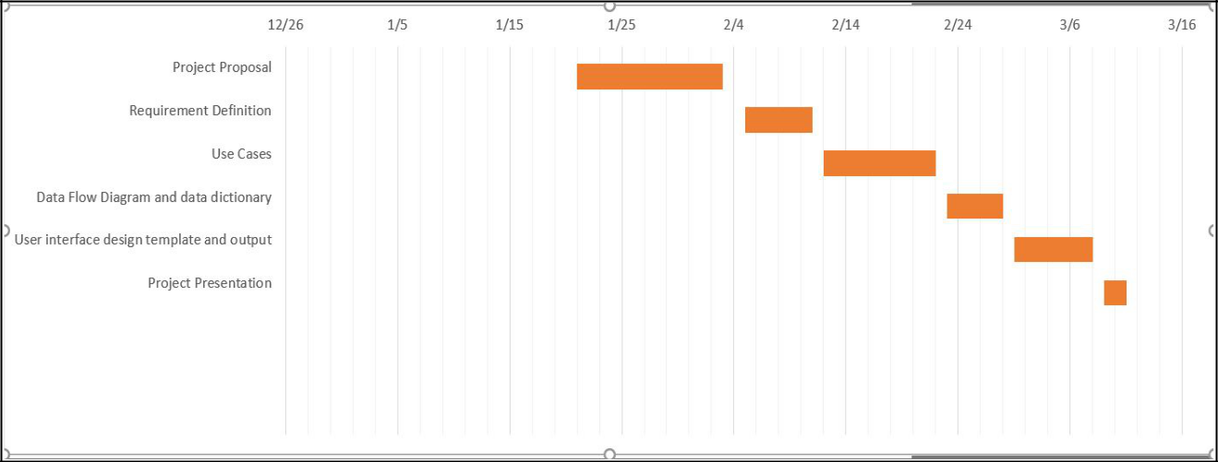

Business Need

A lot of freelancers and startup have been coming out with brilliant project ideas but lack the place and facilities to work on their projects. The project of Co-working space has been initiated to develop a system which will provide freelancers and startups with the option of renting an office space and supporting facilities to work seamlessly on their projects. This system will help users rent office space on a daily, monthly or yearly basis with the option of renting the facilities present at the office space.
Freelancers​: Co-working spaces create the best of both worlds for freelancers: The flexibility of choosing your own hours and schedule without isolation. These shared spaces are thus great for freelancers. A feeling of community is created for those that would otherwise be forced to work alone at home or a coffee shop.
Start-Ups ​: Start-ups appreciate the flexibility of coworking spaces. Coworking spaces don’t come with the high costs and commitments of a traditional office lease. This system will provide the chance for small teams to interact with others in the space. These spaces also may even help entrepreneurs find a co-founder for their start-up by connecting the right people at the right time.

Business Requirements

Using the coworking spaces, offices can be rented to the start-ups, freelancers, entrepreneurs on a daily, monthly or yearly basis. The office space for a client would be customized with other amenities like network facilities, infrastructure facilities, and transport facilities. The nearest location would be offered to the customers based on their needs. The system should incorporate the below requirements to support the business.

- Create User profile - A customer who wants to rent a coworking space should be able to register on the company website. Once the profile is created, they can proceed with the next steps.

- Select office sites base​d on location and size - Users will enter a preferred location of the office from available options and system will display the details of the chosen office site.

User will select the size of the office and rental details. System will display the estimated cost based on the selection.

- Offer office related services​- Once the coworking space is selected,the system should display the default services provided like electricity, Air conditioning, common cafeteria, restrooms. Then the user will be allowed to choose optional services like internet, computers, wifi, and printers. The additional charges for each service would be displayed and added in the final bill as soon as the user selects additional services.

- Provide Transportation service - The pickup and drop services would be provided to the employees of each registered organization at additional charges. Total charges will be calculated based on a number of employees in the organization. Transportation charge will be fixed per employee irrespective of the distance.

- Process the online payment for customer​- Once the coworking space is customized with additional services, a final quote will be generated and shown on the screen. The user will be given an online payment option to facilitate the payment via credit card or net banking.
- Assign and manage user rewards ​- The system will store the booking history in the user profiles. Monthly and yearly subscriptions would be offered reward points. These reward points will allow the customers to redeem the points in their subsequent bookings.

- Manage online platform and datastores: The system is responsible for updating and maintaining the website and datastores on the directions of the system administrator.

Business Value

It is expected that the co-working space will bring in sales and revenue by implementing the above-mentioned system. The major source of revenue comes from the reserving the space through the company website. We can expect additional revenue from the amenities(computers, wifi, printers) provided. We can expect to gain a new revenue stream from transportation services. The revenue can be increased by the rewards system introduced.

Conservative estimates of tangible value to the company include the following:

- $250,000 per month in sales from space reservations.

- $20,000 per month in sales from amenities.

- $10,000 per month in sales from transportation services.

Conservative estimates of intangible value to the company can include advertisement and publicity. The brand value can be increased through this, which in turn helps in increasing the revenue of the company.

Special Issues and constraints:

The system is not available offline. Without active internet connection, users will not be able to reserve any office spaces or avail the transportation service provided.

Scope of the System:

The scope of this system is to have an efficient system which will help the start-ups and freelancers who want to rent the office space on daily/monthly/annual basis. The project will take around 2 years to develop completely as our system integrates the offices from 6 different locations. The entire system is targeted to be developed in 16 months and last 8 months will be dedicated to testing which will help us to generate a feasible system.

Functional Requirements:
Process Oriented:

  - Create User profile:

1.1 System should allow a new user to sign up using email id.

1.2 User should be able to set the username and password at the time of signing up.

1.3 After signing up, the system should send account authentication link on the registered email id.

1.4 The existing users should be able to log in into the system using username and password

- Select office sites based on location and size:

2.1 The system must provide users with a list of available office locations to choose
from.

2.2 The system must display the pictures and description of the office site chosen.

2.3 The system should ask the user to select the office size and rental details like startdate, and rent option as daily, monthly and annual. System should provide two separate options for freelancer and start-up to proceed further.

2.4 The system must display the chosen office details like office size, estimated rental charges and rental duration.

- ​Offer office related services

3.1 After selecting the office site based on the location and size, system should display the default office services provided.

3.2 The system should display the list of optional services like desktop/laptop, internet, and printer.

3.3 The system should display the cost of optional services for each rent option (daily,monthly and annual).

3.4 Bases on the optional services selected and corresponding charges, additional costs must be added to the rental charges.

- Provide Transportation service:

4.1 The system must provide an option to use transportation services and display the charges for daily, monthly and annual options.

4.2 The System should allow to choose the number of employees making use of transportation services.

4.3 The system should display the list of bus stations for the transportation service.

4.4 The system should calculate and display the total charges incurred.

- ​Process the online payment for customer:

5.1 After selecting the rent option and additional services, the system should display the order summary and ask the user to check out.

5.2 After checking out, the user should be navigated to the payment screen. Payment screen should display the total amount and payment details.

5.3 System should allow to redeem the reward points available with the customer’s account.

5.4 Once the user confirms the payment, the system should display the payment status.

6. Assign and Manage User rewards :

6.1 The system should automatically assign 10% of monthly rent, reward points to users.

6.2 The system should automatically assign 20% of yearly rent, reward points to users.

6.3 The system should allow users to redeem the reward points in their subsequent reservation or booking.

7. Manage Online platform and datastores:

7.1 The system should update the datastores with new entries of office location and services provided when needed by the system administrator.

7.2 The system should notify the system administrator about the payments made and corresponding details.

Information-Oriented:
- The system will store the user’s username and password.

- The system must store a user’s booking history.

- The system should store the default services offered.

- The system must store the rent option, and optional services like internet, computers, WiFi, and printers.

- The system must store the transportation opted by the customers.

- The system must store the reward points of monthly and yearly subscribers.

- The system must store office locations.

Non Functional Requirements:

Operational:

- The system should support MYSQL database to store the bookings, co-working space locations and other services provided.

- The system should be compatible with Windows 7, 8, 10 and Mac operating system.

- The system access control should be remote manageable since the space owner is not always on-site.

- Website should be compatible with hand-held devices/ mobile browsers.

- A separate backup server should be present on different geographical location as backup to the primary server.

Performance:

- The system needs to allow 24/7 access.

- The website should be accessible throughout the year except for the maintenance period of the website, which takes place once in 3 months.

- The system should be able to update changes within 7 seconds of every booking.

- The system should be able to process the transactions typically within 5 seconds.

- The system should be able to store the data at least upto 1TB.

Security:

- Allocate unique credentials and a password to each user for Wi-Fi connection to protect customer’s data from being hacked.

- The system should include spyware and web protection to keep the system safe from virus attacks.

- Only the system administrator has access to the system to add or edit the services provided.

Cultural and Political:

- The co-working space should comply with state and federal laws, regarding the working and location acquisition.

- The website must be available in multiple languages.

- The user details should be protected under ‘American Customer Information Protection Act’.

Use Cases :

The use cases will help in capturing the requirements of a system. Each business requirement will translate to a use case. The sequential steps in the use case will derived from the process requirements of the system. This helps us determine the interaction between the user and system. We have seven major use cases for the Co-Hoots.


Use Case Name​: ​Create User Profile | ID: UC-1 | Priority: High
 | ​ ​ | ​ ​

Actor : ​User

Description: ​The use case describes a new user registration and returning user login into the system for reserving office spaces.

Trigger: ​Customer wants to reserve office space.
Type: ​External
Preconditions: ​1.​​The website is available and running
 | 2. | The user database is up-to-date and online
 | 3. | Updated registered user details
Normal Course: |  |  | Information for steps:
1. | User logs into the system using the requested |  | Username, Password
 | credentials.
2. | User signs up into the system using the |  | First name, last name, Email,
 | requested credentials. |  | username, password
3. | On signing up, system sends the |  | Authentication link
 | authentication link on the registered email ID

4. The system verifies the entered details
5. If the entered details are correct: |  |  | Login credentials
a. The system displays the user account
page |  |  | User account page
6. If the entered details are incorrect:
a. The system displays an error
message and displays the user login
page again. |  |  | Error notification
7. If the user forgets the username or
password:
a. The systems prompt username/message |  |  | Recovery message
Recovery options.
Post-conditions: ​The user is logged in the system to book or reserve.
Summary Input |  | Source | Output | Destination
Username, passwords |  | User | User account | User database
 |  |  | page
First name, last name, Email, username, |  | User | Error | User
passwords |  |  | notification
Authentication link |  | User | Recovery | User
 |  |  | message
Login credentials |  | User


Use Case Name​:​​Select | ID: UC-2 | Priority: High
office sites based on | ​​ | ​​
location and size​.
Actor : ​User

Description: ​The user will select the office site based on the location and the size, system will display the description and the details of the chosen office site.

Trigger: ​The user selects the location and size of the office site from the available option
Type: External​

Preconditions: ​User is logged into the system
Normal Course : |  |  | Information for steps:
1.0 Sort office sites based on the location and
size
1. | The user selects the preferred location |  | Preferred location
 | from the available drop down menu. |  | ​Details of the chosen location
2. | The system retrieves and displays the
 | pictures, description, and the map of the
 | chosen office site. (Alternative course
 | 1.1)
3. | The user selects the number of room(for |  | Preferred size
 | startup) or number of desk (freelancer)
 | from the available drop down menu.
4. | The system retrieves the cost based on |  | Cost for rented space
 | the location and size selected.
5. | The system displays this cost to the user. |  | Cost details
6. | The system asks for confirmation to rent |  | User confirmation
 | this space.
7. | The system will store the details of the |  | Office rent details
 | rent transaction in the office rent
 | transaction datastore
Alternate Course:
1.1 The office site is already reserved​​(branch at
step 3)
1. The system asks the user if he wants to |  |  | User change authentication
modify the selection or to cancel the order.
2a. The user wants to modify the search. |  |  | New Location and size
3a. The system displays the pictures, |  |  | ​Details of the chosen location
description, and the map of the chosen office
site.
4a. The system displays cost and asks for |  |  | User confirmation
user confirmation.
2b. The user does not want to proceed |  |  | Cancellation
further
3b. The system terminates the use case.
Postconditions:
1. | The preferred office site is finalized​.
2. | Rent Office rent transaction ​details database is updated.
Summary Input |  | Source | Output |  | Destination
Preferred location |  | User | Office rent details |  | Rent transaction

Details of the chosen | Office and services |  |  |  |  | datastore
location | details datastore |  |  |  | Cost details | User
Preferred size | User
User confirmation | User
Cost for rented space | Office and services
 | details datastore
User change | User
authentication
New Location and size | User
Cancellation | User
Use Case Name​:​Book Office |  |  | ID: UC-3 | Priority: High
services |  |  | ​ ​ |  | ​ ​
Actor : ​User


Description: ​The user is prompted to select the services desired for the office space rented.
Trigger: ​User finalizes the office location and proceeds.
Type: ​External

Preconditions:
1. | The preferred office site is finalized​.
2. | The co-working space database has a cardinality which relates the Office Location
 | Datastore with the Services provided Datastore.
3. | Rent transaction details datastore is up to date.
Normal Course: |  | Information for steps:
1.0 Provide the user with office specific
services for selection
1. | The system retrieves the services | Retrieve services provided
 | provided at that specific office
 | location
2. | Display the list of services available | Display Services provided
 | services at that specific office location
3. | User selects the services desired | Select Services
4. | The system displays the charges on | Display cost
 | the basis of the services selected.
5. | The system asks for confirmation to | User confirmation
 | book the services.
6. | The system will store the details of | Service details
 | the transaction in the transaction
 | datastore​.


Post Conditions: ​The office services are booked by the user.
User services datastore is updated

Summary Input | Source | Output | Destination
Retrieve services provided | Office and | Display Services | User
 | services | provided
 | details
 | datastore | Display cost | User
Select Services | User
 |  | Service details | User Services
User confirmation | User |  | datastore


Use Case Name​:​Book | ​​ | ​​
Use Case Name​:​Book | ID: UC-4 | Priority: High
transportation services
Actor : ​User

Description: ​The user selects the preferred location for pick up from the list of bus stations if he chooses to opt for the location service

Trigger: ​User finalizes desired services and proceeds further.
Type: ​External

Preconditions: ​The co-working space database has a cardinality which relates the Office Location Datastore with the Transportation Services provided Datastore. User services datastore is up to date.

Normal Course: |  | Information for steps:
1.0 Provide the user with the option of
booking transportation services.
1. | The user opts for transportation | User selection
 | services.
2. | The system retrieves the list of bus | List of bus station
 | stations.
3. | Display the list of bus stations to the | Display list
 | user.
4. | User selects the number of employees | Number of employees
 | using transportation services.
5. | The system displays the charges for | Display charges
 | the transportation services.
6. | The system asks for confirmation to | Station charge confirmation
 | book the transportation services.

7. The system will store the details of |  | Transportation service details
the transaction in the ​transportation
service ​transaction datastore​.
Post conditions: ​The transportation services are booked by the user.
Summary Input | Source | Output | Destination
User selection | User | Display list | User
List of bus station | Office and services | Display charges | User
 | details datastore | Transportation | User Transportation
Number of employees | User | service details | Datastore
Station charge | User
confirmation


Use Case Name​:​Process | ID: UC-5 | Priority: High
the online payment for | ​ ​ | ​ ​
customer
Actor : ​User

Description: ​The user confirms the order and proceeds with the payment.
Trigger: ​User selects the rent option and the additional services and confirms the order.
Type: ​External

Preconditions:

1. The user selects the desired location of the co-working space, time period, transportation services and other desired services.
2. The cart contains the order placed by the customer.

Normal Course: | Information for steps:
1.0 The transaction summary is displayed.
1. The system retrieves the data | Transaction summary page.
from the rent transaction datastore,
user services transaction datastore
and user transportation datastore
and summarises the transaction
details.
2. The system displays a message | Order confirmation page.
asking if the user wants to confirm


the order and proceed to pay.
(Branch to 1.1)
3. The user selects the payment | Payment page.
option.
4. The user enters debit/credit card | Credit card details.
details.
5. Order confirmed and the | Payment transaction details
database updated with the user
reservation details.
6. Database updated with user | User payment details
payment details for future
transactions.
7. Order confirmation notification | Confirmation email.
sent to the user email-id.
Alternate course:
1.1 The system provides the user with the
option of redeeming reward points(Branch
at step 2)
1. The user can select if he wants to
redeem reward points or save it for
the next reservation.
1a. The user chooses to redeem. | Redeem points
1b. New transaction summary with | Payment page
the applicable discount is displayed.
2a. The user chooses not to redeem | Cancellation
and keep the reward points intact.
2b. The system continues with the | Payment page
previous, unchanged transaction
summary.

Exceptions:
1.2 If the user enters wrong debit/credit card details.

a. The system notifies the user of the incorrect card information and redirects to the same page till the correct information is entered.

Post conditions:
1.Payment process completed successfully.
2.User occupies the reserved space.

Summary Input | Source | Output | Destination
Transaction summary page | System | Payment transaction | Payment transaction
 |  | details | datastore
Order confirmation page | System

 |  | User payment details | User datastore
Payment page | User
 |  | Confirmation email | User
Credit card details | User
Redeem points | User
Cancellation | User


Use Case Name​:​Assign and | ID: UC-6 | Priority: High
Manage User rewards | ​ ​ | ​ ​
Actor : ​User

Description:​The user is assigned user rewards based on the amount of money spent collectively on the rented space and services selected.

Trigger: ​User successfully completes payment.
Type: ​External

Preconditions: ​User has completed the payment process successfully.
Normal Course: |  | Information for steps:
1.0 The ​user rewards are calculated on the
basis of the total cost of payment.
1. | The payment details for the customer | Payment details
 | are retrieved from the payment
 | datastore.
2. | The system calculates the user reward | Reward calculation
 | points which is 10% of the payment
 | made.
3. | The system stores these points in the | User reward details
 | user rewards datastore.
4. | The system displays the user reward | Display Reward points
 | points to the user.

Post conditions: ​User rewards are assigned to the user and can be used for further payments.
Summary Input | Source | Output | Destination

Payment details | Payment detail | User reward details | Reward details
 | datastore |  | datastore
Reward calculation | Payment detail | Display Reward | User
 | datastore | points


Use Case Name​:​Manage | ID: UC-7 | Priority: High
online platform | ​ ​ | ​ ​
Actor : ​System Administrator

Description: ​The system administrator will maintain and update the online platform details.
Trigger: ​Office location details need to be updated.
Type: ​External

Preconditions: ​The datastore has the existing details of the office location and other services
Normal Course: |  | Information for steps:
1.0 Maintain and update the online platform
1. | The system authenticates the user. | User login details
2. | The system administrator updates the | New location and services details
system with new details of office locations
and other services.
3. The system displays a message asking the |  | Updation confirmation page
user to confirm the updated details.
4. | The office and services details datastore is | New office location and services details
updated.
5. | The system notifies the administrator of | New user payment details
the new user once the payment is made.
6. The payment transaction datastore is |  | New payment details
updated.
Post conditions:
 | 1. The datastores are updated with office location details and new services offered.
 | 2. The system administrator will be notified of the new payments completed.

Summary Input | Source | Output | Destination
User login details | System | Updation | System administrator
 |  | confirmation page
New location and service | System
details |  | New office location | Office and service
 |  | and services details | details datastore
 |  | New user payment | System administrator
 |  | details
 |  | New payment details | Payment transaction
 |  |  | datastore

DATA FLOW DIAGRAMS:

CONTEXT DIAGRAM:

The first DFD in every business process model, whether a manual system or a computerized system, is the context diagram. As the name suggests, the context diagram shows the entire system in context with its environment. All process models have one context diagram.The context diagram shows the overall business process as just one process(i.e., the system itself) and shows the data flows to and from external entities. In Co-Hoots we have two external entities one is User and the other is System Administer. Our system will interact with external system to retrieve and confirm the payment information.
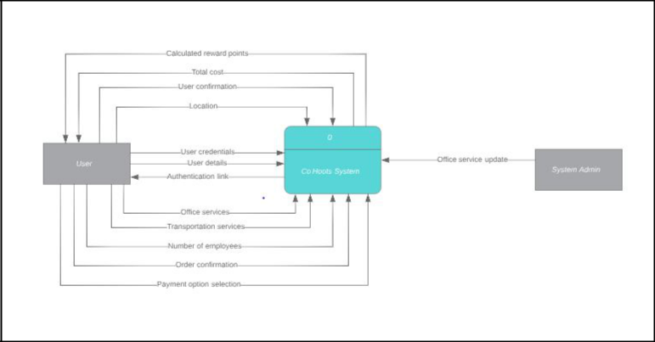

LEVEL 0 DFD
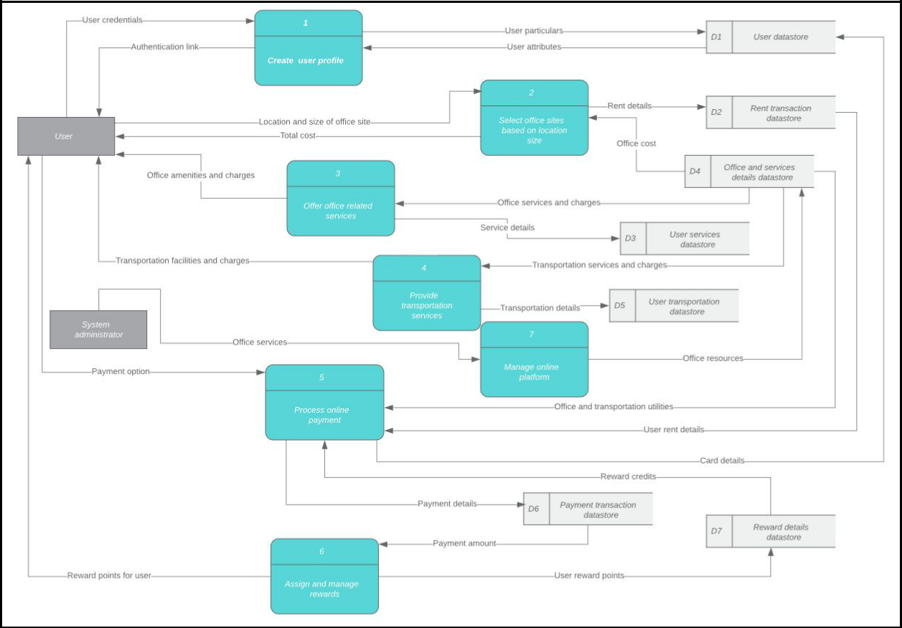
LEVEL 1 - PROCESS 1
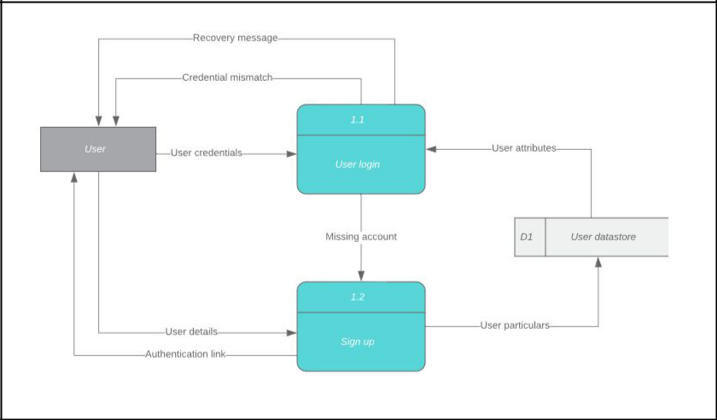

LEVEL 1 - PROCESS 2
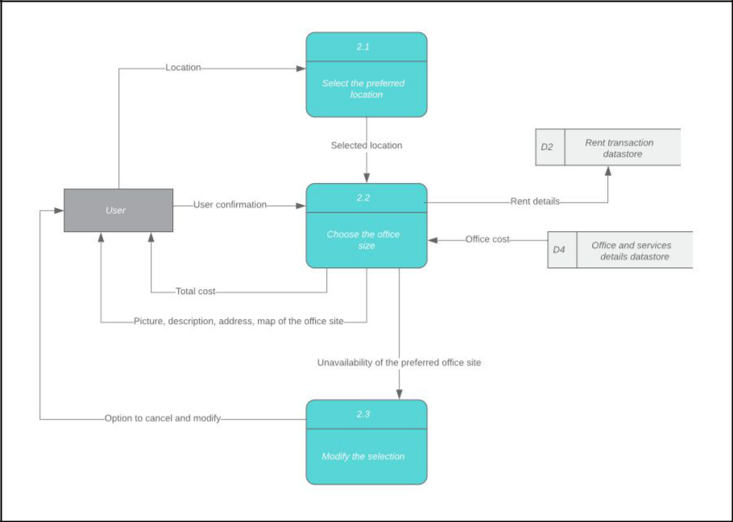

LEVEL 1 - PROCESS 3
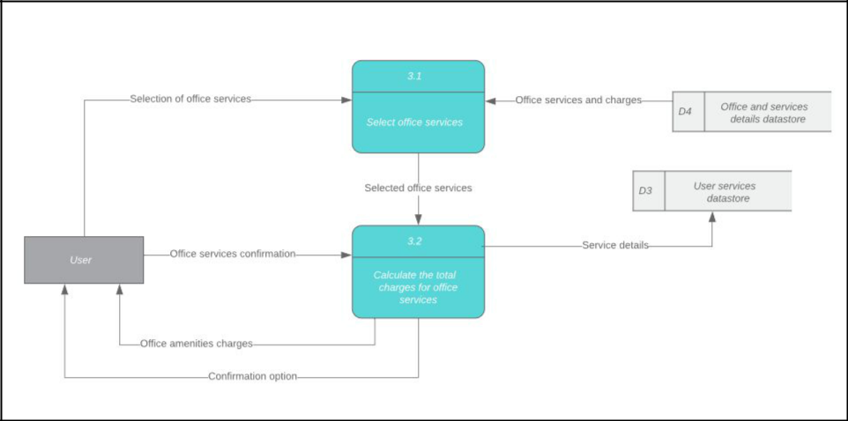
LEVEL 1 - PROCESS 4
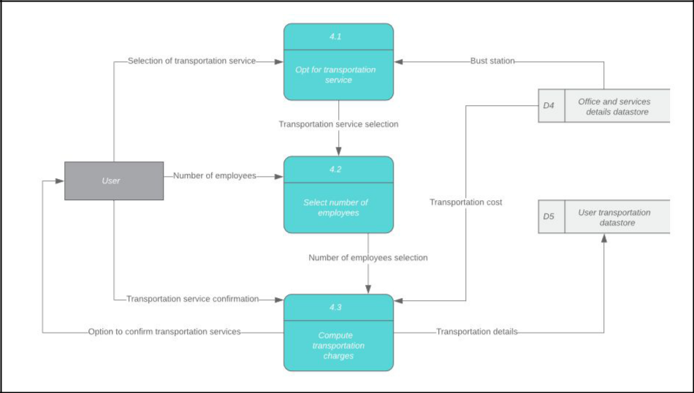

LEVEL 1 -PROCESS 5
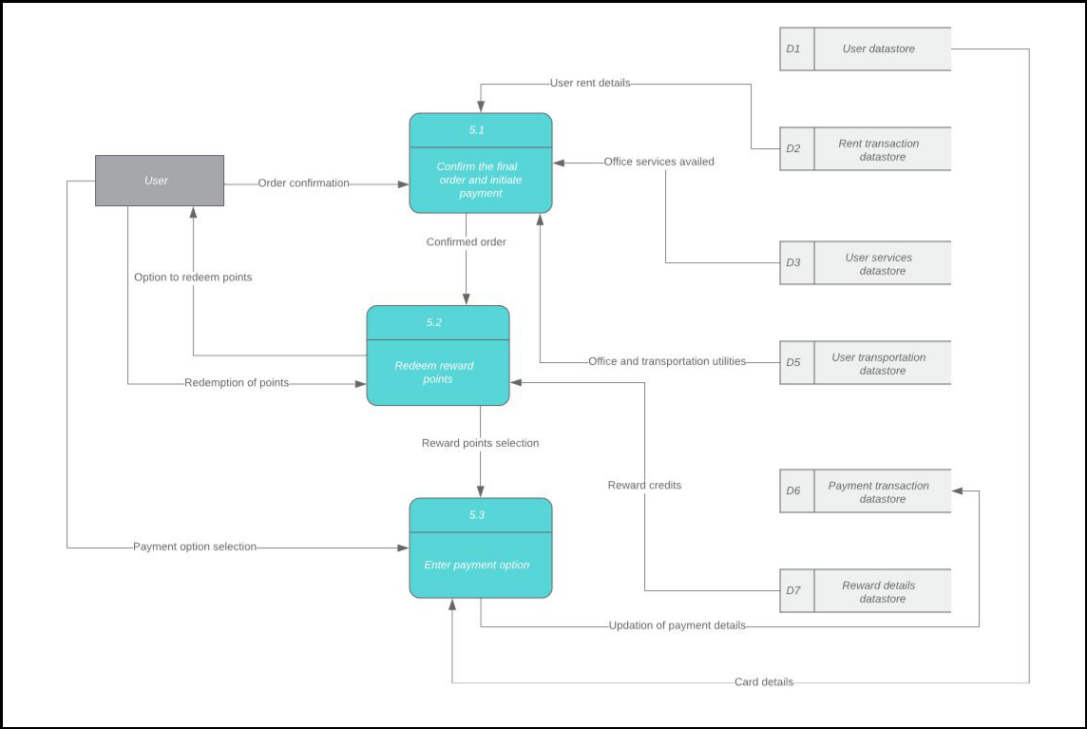

LEVEL 1 - PROCESS 6
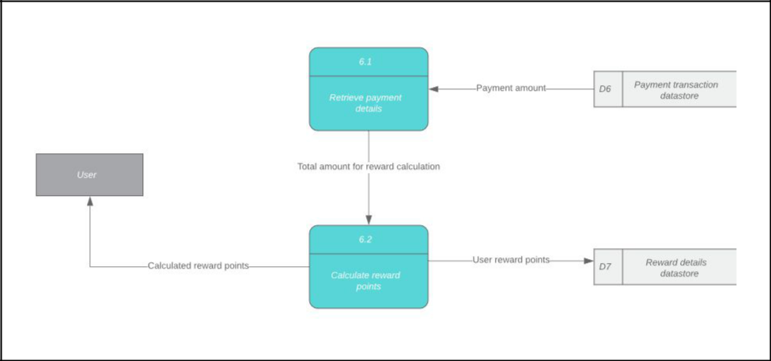
LEVEL 1 - PROCESS 7
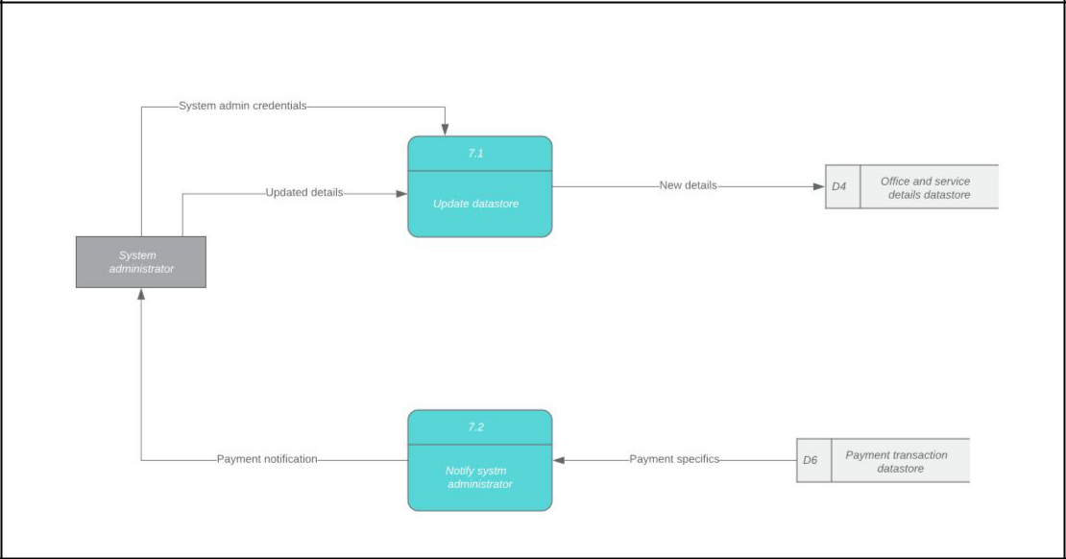

Data Dictionary:

D1: User Database

 |  | Default
Column_Name | Data Type | Value | Description
First_Name | VARCHAR(20) | Null | The user's first name
Last_Name | VARCHAR(20) | Null | The user's last name
User_ID | VARCHAR(10) | Null | System generates unique User ID once
 |  |  | user account is created
User_Email | VARCHAR(20) | Null | User's email address
User_Pwd | VARCHAR(20) | Null | User's password
User_Address | VARCHAR(100) | Null | User's address
User_PhoneNumber | Number(10) | 0000000000 | User's phone number
User_Zipcode | Number(5) | 00000 | User's area Zipcode
User_City | VARCHAR(20) | Null | User’s city
User_State | VARCHAR(2) | Null | User's state

D2: Rent transaction Database

 |  |  |  | Default
Column_Name | Data Type |  |  | Value |  |  | Description
User_ID | VARCHAR(10) |  |  | Null |  |  | User ID of user
Date_Time | DATETIME |  |  | Current date |  |  | Date and time of conversation
 |  |  |  |  |  |  | Number of desks selected by the
Number_of_Desks | INTEGER(5) |  | 1 |  |  |  | freelancer
Number_of_Rooms | INTEGER(5) |  | 1 |  |  |  | Number of rooms selected by the startup
Mode_Of_Reservation | ENUM |  |  | Daily |  |  | Mode of reservation selected by the user
Office_locationID | VARCHAR(10) |  |  | Null |  |  | Office location ID
D3: User Services Database
 |  |  |  | Default
Column_Name |  | Data Type |  | Value |  | Description
User_ID |  | VARCHAR(10) |  | Null |  | UserID of the user
Printer_ID |  | VARCHAR(10) |  | Null |  | PrinterID of the printer availed by the user
System_ID |  | VARCHAR(10) |  | Null |  | SystemID of the system availed by the user
Confirmation_ID |  | VARCHAR(10) |  | Null |  | Confirmation ID of the user.
Internet_service_Avail
ed |  | VARCHAR(10) |  | Null |  | If the user availed the internet services
D4: Office and services details database
 |  |  |  |  | Default
Column_Name |  | Data Type |  |  | Value |  |  | Description
Office_ID |  | VARCHAR(10) |  |  | Null |  |  | Unique office ID for each office
Service_ID |  | VARCHAR(10) |  |  | Null |  |  | Unique service ID
TransportService_opt |  | BOOLEAN(1) |  |  | True |  |  | Store if the user has opted for
 |  |  |  |  |  |  |  | transportation services
Office_Address |  | VARCHAR(10) |  |  | Null |  |  | Address of the office
Office_Phone |  | NUMBER(10) |  |  | Null |  |  | Phone number of office
Available_Room |  | INTEGER(5) |  |  | 00000 |  |  | The number of rooms available

Room_ID | VARCHAR(10) | Null | ID of room number
From_Time | DATETIME | Current date | From time of booking
To_Time | DATETIME | Current date | To time of booking

D5: User transportation database

Column_Name | Data Type | Default Value | Description
Transportation_Service_ID | Varchar(10) | Null | ID of the transportation
 |  |  | service availed
Customer_ID | Varchar(10) | Null | Unique ID of the
 |  |  | customer
Office_Address | Varchar(30) | Null | Address of the office
Station_Address | Varchar(30) | Null | Address of the pick up
 |  |  | station.

D6: Payment transaction database

Column_Name | Data Type | Default Value | Description
 |  |  | Payment ID of the payment done for a
Payment_ID | VARCHAR(10) | Null | booking
User_ID | VARCHAR(10) | Null | User_ID of user
Booking_ID | VARCHAR(10) | Null | Booking ID of the parking spot
Name_on_Card | VARCHAR(10) | Null | Name on credit/debit card
Card_Number | INTEGER(16) | 0000000000000000 | Credit/Debit Card Number
Expiration_Date | DATE | Current Date | Expiry Date on card
CVV | INTEGER(3) | 000 | Unique ID on card
Payment_Status | BOOLEAN(1) | False | Status of payment

D7: Reward details database

 |  |  | Default
Column_Name |  | Data Type | Value | Description
 |  |  |  | Payment ID of the payment done for a
Payment_ID |  | VARCHAR(10) | Null | booking
User_ID |  | VARCHAR(10) | Null | User_ID of user
 |  |  |  | Points earned after the booking is
Points_Earned |  | INTEGER(6) | 000000 | completed
Reservation_ID |  | VARCHAR(10) | Null | User reservation ID
Monthly | reward |  |  | Percentage of points for monthly mode
percentage |  | INTEGER(3) | 000 | of reservation
Annual | reward |  |  | Percentage of points for annual mode
percentage |  | INTEGER(3) | 000 | of reservation

Program Structure Chart:
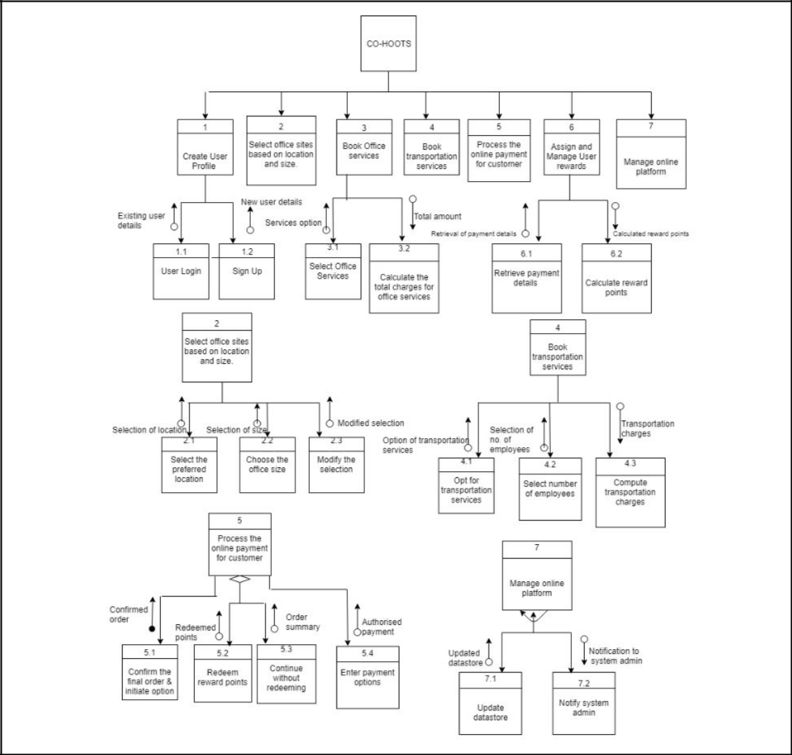

UI Screenshots:

Future Scope:

Coworking spaces are going to revolutionize and disrupt the way that we know and understand traditional office spaces and environments all across the globe. The future of co-working will include building trusted community of like-minded peers, partners, and supporters to exchange thoughts and collaborate on projects within creative spaces designed to accelerate learning. Co-working spaces will introduce great thought leaders, connect entrepreneurs with new collaborators, all in service of creating solutions-focused businesses and building a better world we know is possible.

Conclusion:

The Co working space system will allow the freelancers and startups to rent the office sites as per their needs and convenience. We are also providing users with the office services and transportation services to provide the user with seamless working and easier commute to the offices. The user reward points can also be used to get discount on future orders.

References:

- https://www.futureofeverything.io/future-coworking-spaces/

